Task_1_File Creation:
1.Create a directory called ""my_folder"", navigate into it, and create a file named ""my_file.txt"" with some text. Then, create another file named ""another_file.txt"" with some text. Concatenate the content of ""another_file.txt"" to ""my_file.txt"" and display the updated content. Finally, list all files and directories in the current directory.

Answer:
ubuntu@ubuntu-VirtualBox:~$ ls
Desktop Downloads Pictures Templates
Documents Music Public Videos
ubuntu@ubuntu-VirtualBox:~$ pwd
/home/ubuntu
ubuntu@ubuntu-VirtualBox:~$ mkdir my_folder
ubuntu@ubuntu-VirtualBox:~$ cd my_folder/
ubuntu@ubuntu-VirtualBox:~/my_folder$ echo "this is my_file" > my_file.txt
ubuntu@ubuntu-VirtualBox:~/my_folder$ echo "this is another_file" > another_file.txt
ubuntu@ubuntu-VirtualBox:~/my_folder$ cat another_file.txt >> my_file.txt
ubuntu@ubuntu-VirtualBox:~/my_folder$ cat my_file.txt
this is my_file
this is another_file
ubuntu@ubuntu-VirtualBox:~/my_folder$ ls -l
total 8
-rw-rw-r-- 1 ubuntu ubuntu 21 Jul 20 19:33 another_file.txt
-rw-rw-r-- 1 ubuntu ubuntu 37 Jul 20 19:33 my_file.txt
ubuntu@ubuntu-VirtualBox:~/my_folder$
Screenshot:
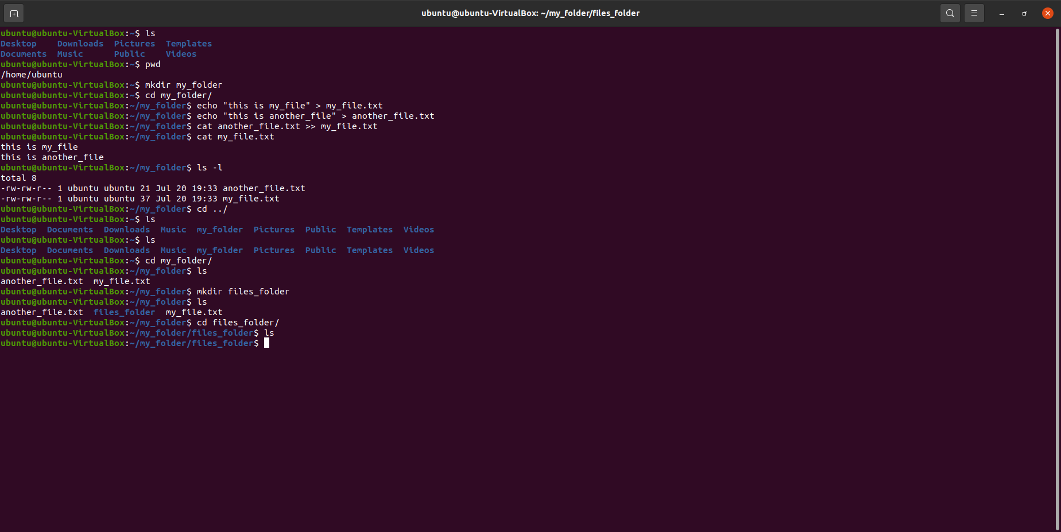

2. Create 20 files with .txt extensions and rename the first 5 files to .yml extension and Print the latest created top 5 files among the total no of files.

Answer:
ubuntu@ubuntu-VirtualBox:~$ cd testing_vicky/
ubuntu@ubuntu-VirtualBox:~/testing_vicky$ ls
ubuntu@ubuntu-VirtualBox:~/testing_vicky$ nano script.sh
ubuntu@ubuntu-VirtualBox:~/testing_vicky$ cat script.sh
touch file{1..20}.txt
for i in {1..5}; do
mv file$i.txt file&i.yml
done
ubuntu@ubuntu-VirtualBox:~/testing_vicky$ chmod +x script.sh
ubuntu@ubuntu-VirtualBox:~/testing_vicky$ ./script.sh
./script.sh: line 3: i.yml: command not found
./script.sh: line 3: i.yml: command not found
./script.sh: line 3: i.yml: command not found
./script.sh: line 3: i.yml: command not found
./script.sh: line 3: i.yml: command not found
ubuntu@ubuntu-VirtualBox:~/testing_vicky$ nano script.sh
ubuntu@ubuntu-VirtualBox:~/testing_vicky$ ./script.sh
./script.sh: line 5: i.yml: command not found
./script.sh: line 5: i.yml: command not found
./script.sh: line 5: i.yml: command not found
./script.sh: line 5: i.yml: command not found
./script.sh: line 5: i.yml: command not found
ubuntu@ubuntu-VirtualBox:~/testing_vicky$ nano script.sh
ubuntu@ubuntu-VirtualBox:~/testing_vicky$ nano script.sh
ubuntu@ubuntu-VirtualBox:~/testing_vicky$ ./script.sh
ubuntu@ubuntu-VirtualBox:~/testing_vicky$ ls
file file11.txt file13.txt file15.txt file17.txt file19.txt file20.txt file3.yml file5.yml file7.txt file9.txt
file10.txt file12.txt file14.txt file16.txt file18.txt file1.yml file2.yml file4.yml file6.txt file8.txt script.sh
ubuntu@ubuntu-VirtualBox:~/testing_vicky$ ls -lt | grep -n 5
7:-rw-rw-r-- 1 ubuntu ubuntu 0 Jul 20 20:01 file15.txt
17:-rw-rw-r-- 1 ubuntu ubuntu 0 Jul 20 20:01 file5.yml
22:-rwxrwxr-x 1 ubuntu ubuntu 85 Jul 20 20:01 script.sh
ubuntu@ubuntu-VirtualBox:~/testing_vicky$ ls -lt | head -n 5
total 4
-rw-rw-r-- 1 ubuntu ubuntu 0 Jul 20 20:01 file10.txt
-rw-rw-r-- 1 ubuntu ubuntu 0 Jul 20 20:01 file11.txt
-rw-rw-r-- 1 ubuntu ubuntu 0 Jul 20 20:01 file12.txt
-rw-rw-r-- 1 ubuntu ubuntu 0 Jul 20 20:01 file13.txt
ubuntu@ubuntu-VirtualBox:~/testing_vicky$ ls -lt | grep .yml
-rw-rw-r-- 1 ubuntu ubuntu 0 Jul 20 20:01 file1.yml
-rw-rw-r-- 1 ubuntu ubuntu 0 Jul 20 20:01 file2.yml
-rw-rw-r-- 1 ubuntu ubuntu 0 Jul 20 20:01 file3.yml
-rw-rw-r-- 1 ubuntu ubuntu 0 Jul 20 20:01 file4.yml
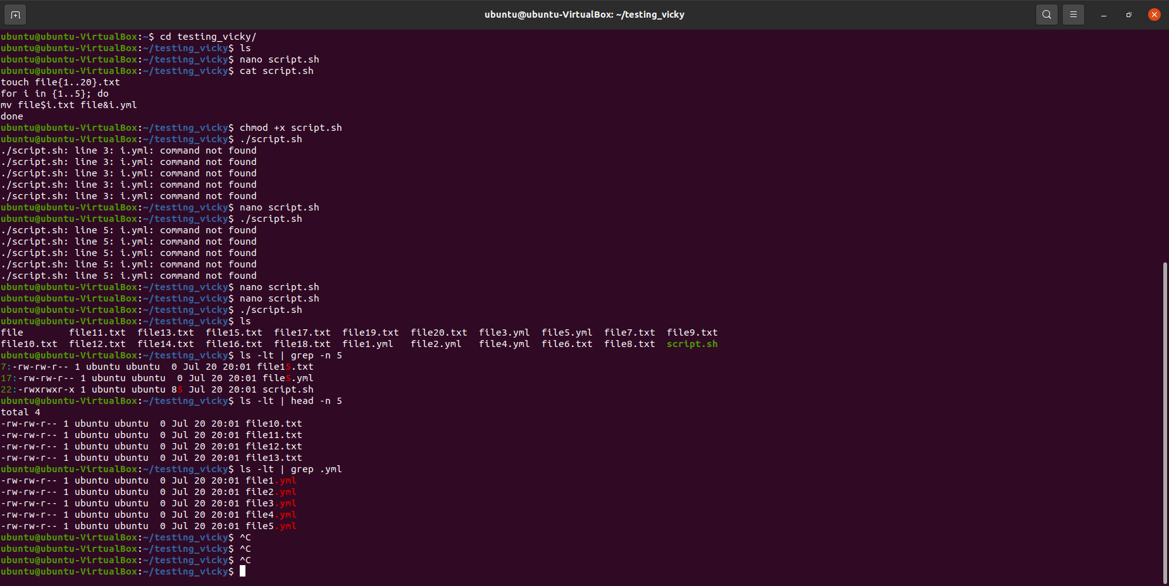
-rw-rw-r-- 1 ubuntu ubuntu 0 Jul 20 20:01 file5.yml
Screenshot:

